Screen shots

S301-Parent Login

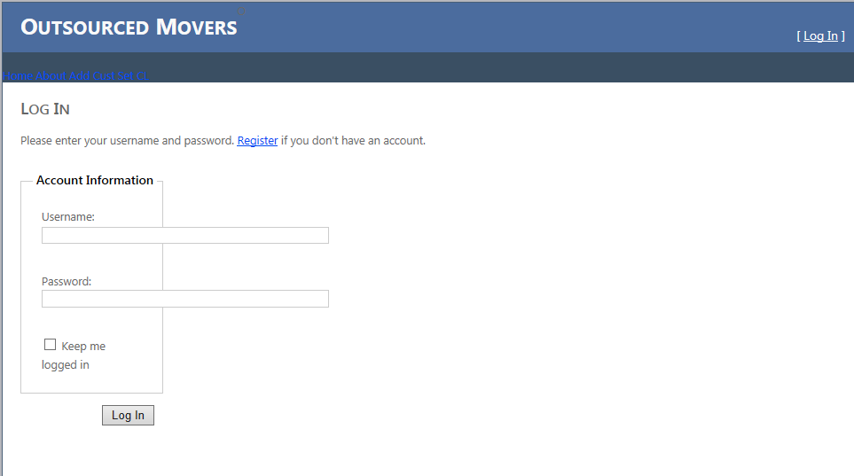

S302-Parent Event View

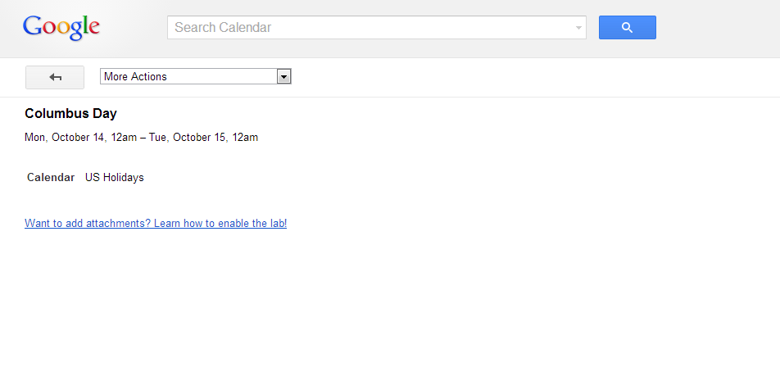

Location: Halloween Maze

Description: Dress up and go to maze.

S401- Teacher Login



S402-Teacher Event View



Location: State Building

Description: View state building